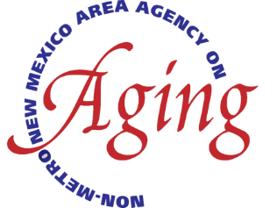

**North Central New Mexico**

**Economic Development District**

**Non- Metro Area Agency on Aging**

3900 Paseo Del Sol Santa Fe, New Mexico 87507

505.395.2668 Toll Free 866.699.4627 [www.ncnmedd.com](http://www.ncnmedd.com)

**Non-Metro AAA Provider Meeting**

**Tuesday November 15, 2022, ~~ 10:00 AM- 4:30 PM**

**NCNMEDD Non-Metro AAA**

**In Person- Center of Recreational Excellence (CORE)**

**4827 N Lovington Highway, Hobbs, NM**

**Registration & Lunch 12:00 PM – 1:00 PM**

**Visitation of Area Providers and CORE Facility 10:00 AM – 12:00 PM**

**\*Individual one-on-one time can be scheduled with Non-Metro Staff during this period**

**Lunch 12:00 PM – 1:00 PM**

**Provider Meeting 1:00 PM – 5:00 PM**

**Welcome & Introductions** Nancy Arias-Macias

* ALTSD Update Secretary Hotrum-Lopez

Denise King

Non-Metro AAA Updates Non-Metro AAA Staff

* LFC Hearings Neil Segotta
* Senior Day – January 19, 2023

**Presentations** Non-Metro Staff

* Program Assessments
  + Kitchen Inspections
  + Perpetual Inventory
  + Policy Postings
  + Program Income
  + Inspections

**Break**

* NSIP Reporting Non-Metro Staff
* Data Reconciliation

**Questions & Answers** Non-Metro Staff

* OAA-SYS Non-Metro Staff

**Adjournment**